***Introduction to Describe IPv6 Core Addressing Concepts***

Exploring ipv6 Networks.

***Comparing IPv4 and IPv6***

Both are Layer 3 addressing.

Both have network / Host address.

Both Layer 4 Protocols.

IPv4 =

1. 32Bit
2. Doted Decimal

IPv6

1. 128Bit
2. Colin notation

In the transition to IPv6, we know IPv4 uses octets and each one contains 8 bits. IPv6 will use _____ and each contains _____ bits.

Hextet: 16

***Binary, Decimal, and Hex***

0-9A-F 16 Total Values

2001:0010 = 0010000000000001:0000000000010000 etc….

When converting an IPv6 hextet to binary, which of the following is the correct conversion for 30B1?

(0011)(0000)(1011)(0001)

***Making IPv6 Addresses Shorter***

Loopback address of 0:0:0:0:0:0:1… is the same as ::1/128

::1111:0:0:1101

In the first rule of shorting the IPv6 address, you can do which of the following?

You can drop leading zeros

***Types of IPv6 Addresses***

What are all these Addresses?

1. Unspecified
   1. Binary – 0000…000
   2. IPv6 - ::/128
2. Loopback
   1. Binary 0000…000
   2. Ipv6 ::/128
3. Global/Public IPADDRESSES
   1. Binary 001…(first three)
   2. IPv6 2000::/3 (2000-3fff)
4. Multicast
   1. Binary 1111:1111…(first eight)
   2. IPv6 FF00::/8
5. Link Local
   1. Binary 1111:111:10…(first ten)
   2. Ipv6 FE80::/10

Which of the following is NOT a type of IPv6 communication?

Broadcast

***Designing IPv6 Addressing***

Our ISP allocated 2001:db8:6783/48 -> 128 bits

2001:db8:6783:XXXX::/64

EUI-64 Gives the ability to create addresses.

You can auto generate the last 64 bits of the address and one way is to use the mac address. 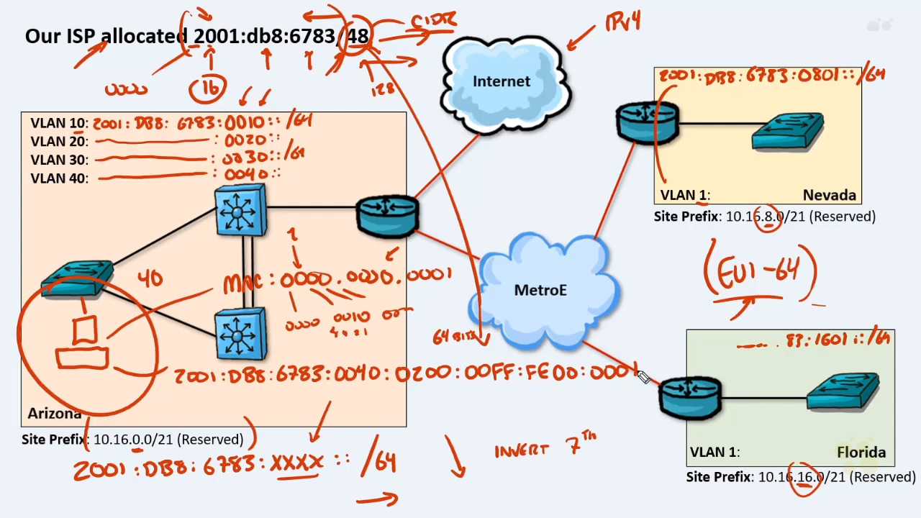

The EUI-64 will allow a host to assign itself an IP address. Which of the following services will no longer be needed?

DHCP – because the EUI allows for self creating an address.

***Configuring IPv6 Addressing***

Unicast routing is the process of forwarding unicasted traffic from a source to a destination on an internetwork. Unicasted traffic is destined for a unique address.

In computer networking, a link-local address is a unicast network address that is valid only for communications within the subnetwork that the host is connected to. Link-local addresses are most often assigned automatically with a process known as stateless address autoconfiguration (SLAAC) or link-local address autoconfiguration,[1] also known as automatic private IP addressing (APIPA) or auto-IP.

#> ipv6 unicast-routing

#> int fa0/1

#> ipv6 address 2001:db8:6783:1601::1/64

Which command will enable IPv6 routing?

Ipv6 unicast-routing

***Configure IPv6 Addressing Lab***

Which of the following is the most common subnet mask used for IPv6 addresses?

/64

***Review Describe IPv6 Core Addressing Concepts***